
2026

MOTA Series Schedule
April 25&26-Michiana Trials-New Paris, IN
May 16&17-Mid-Michigan-Vermontville, MI
May 31-Great Lakes-Metamora, MI
June 14-Metro-Whitmore Lake, MI
June 28-Bent Fenders-Flushing, MI
August 8&9-East Side-Marlette, MI
August 30-Bent Fenders-Flushing, MI
Sept. 13-Great Lakes-Metamora, MI
Sept. 20-Metro-Whitmore Lake, MI
Oct. 3&4-Mid-Michigan-Vermontville, MI
For info, directions & results visit www.motatrials.com
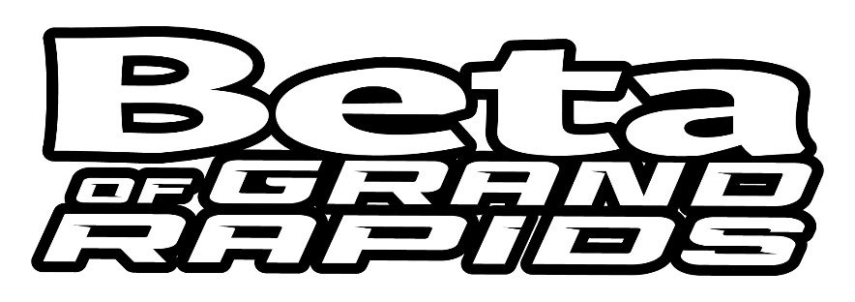
Thank you to all our series sponsors!



